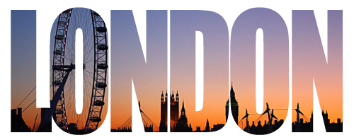
Combining Words and Pictures in Photoshop

- Open your image in Photoshop.

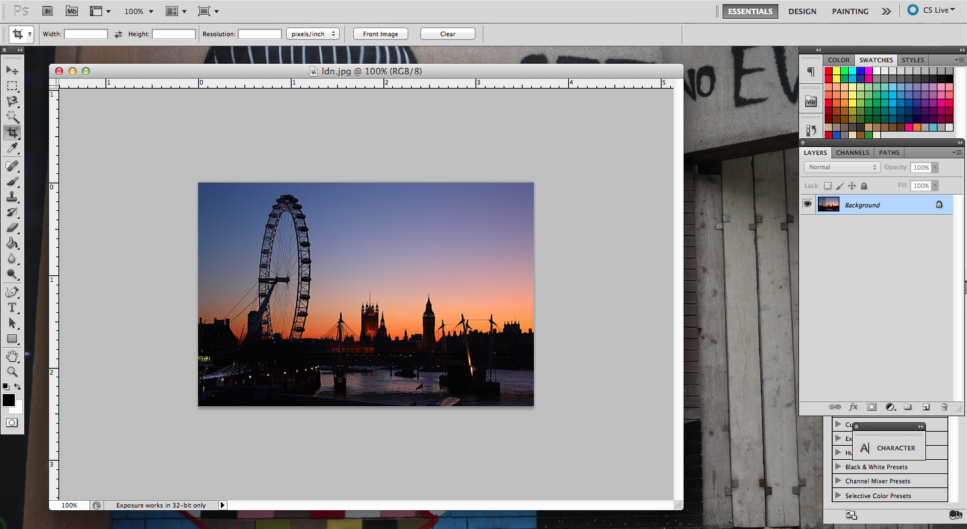

- Duplicate the layer by selecting Layer > Duplicate Layer. Then create a new layer by selecting Layer > New > Layer.

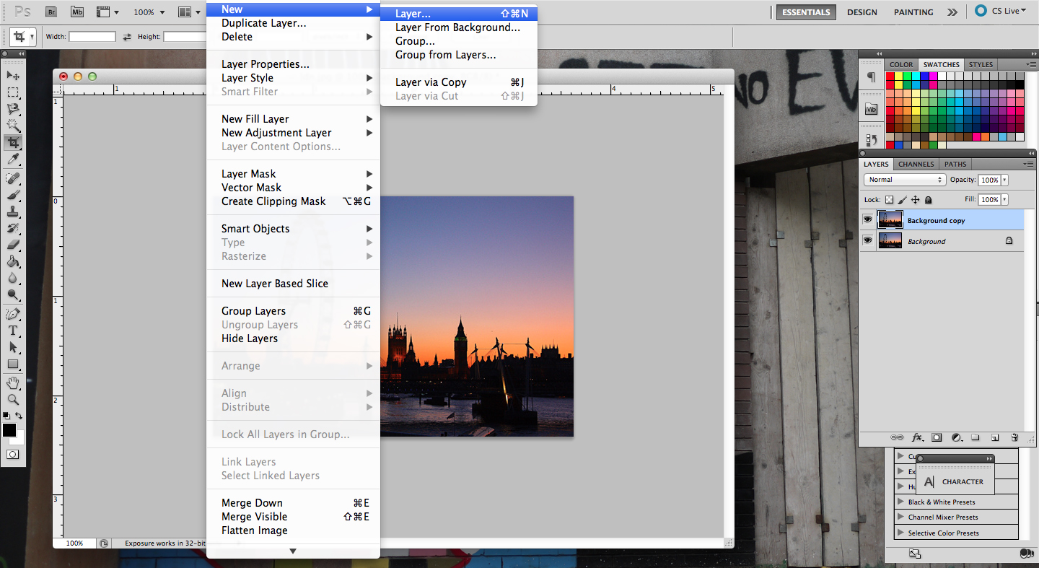

- You will now have three layers, your background, the background copy (from duplicating it) and a new layer. You need to drag the new layer in between the two background layers.

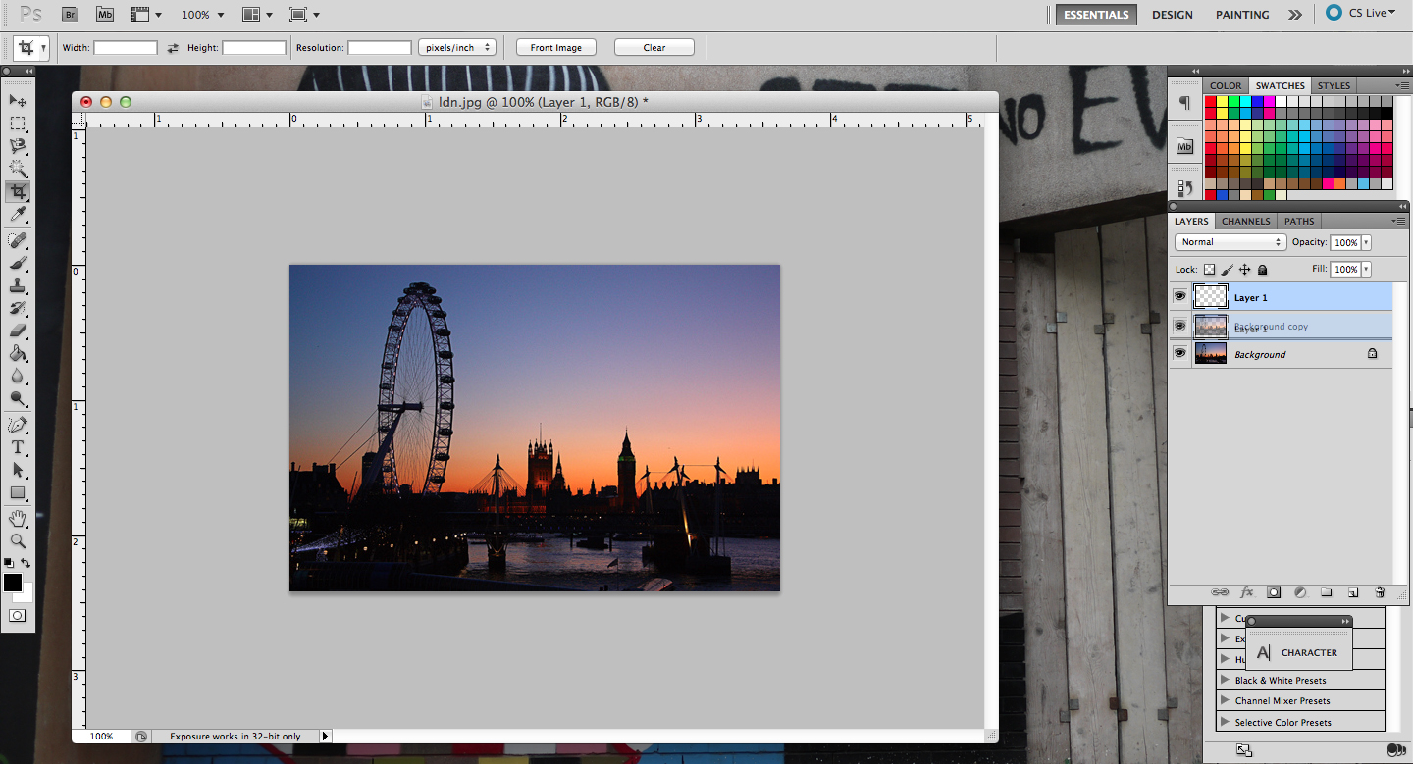

- You now need to fill the new empty layer with white. Do this by selecting Edit > Fill.

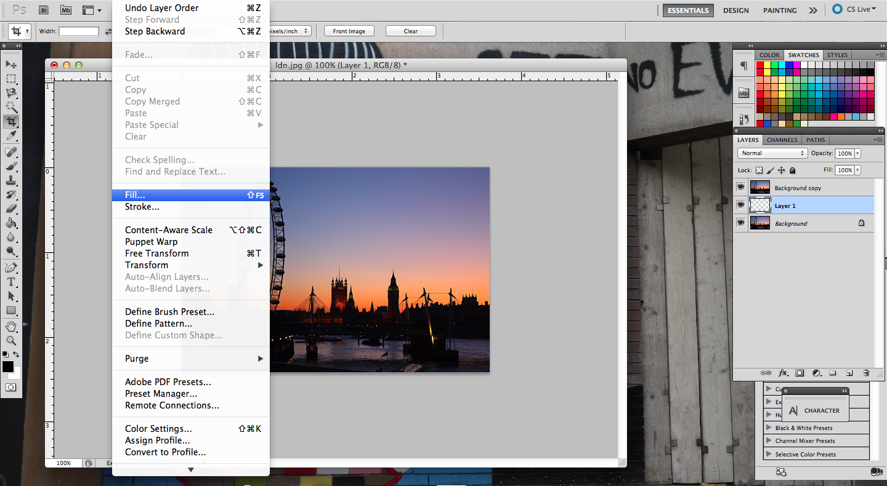

- A pop up box will appear, make sure the drop down menu is selected to ‘White’ and the opacity is 100%. Click OK.

- Now add in your text by selecting the Text Tool (‘T’ on the left hand side). Make sure your text types in white colour.
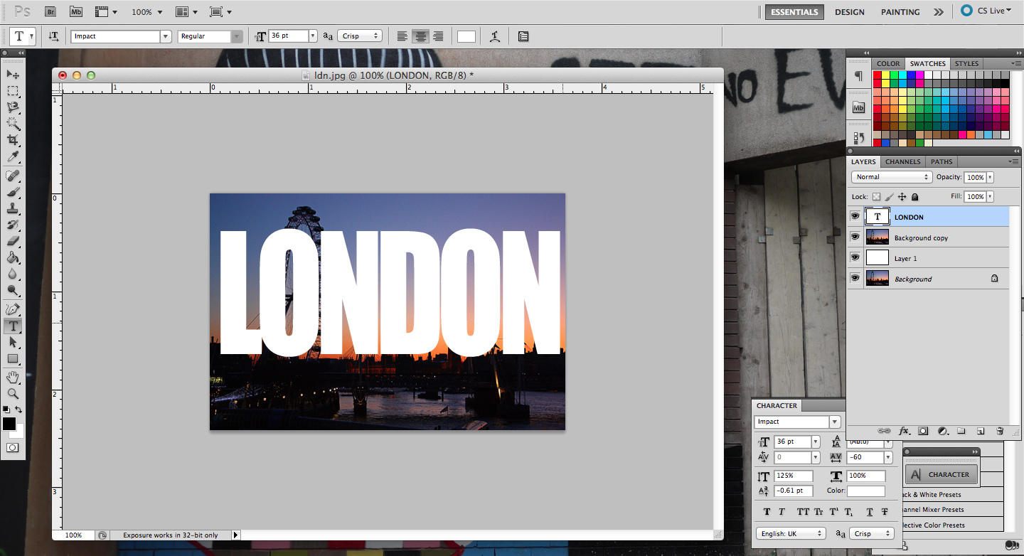

- Drag the text layer above Layer 1, and below the duplicated background layer.
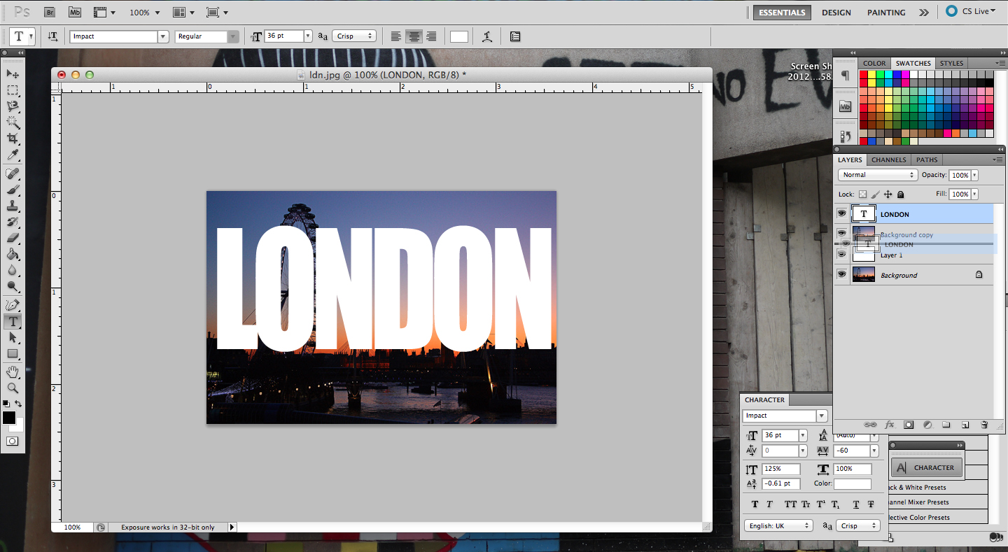

- Select the duplicated background layer (probably titled ‘Background copy’) – you will know it’s selected because it’ll be highlighted blue. From the top menu, select Layer and scroll down to ‘Create Clipping Mask’.

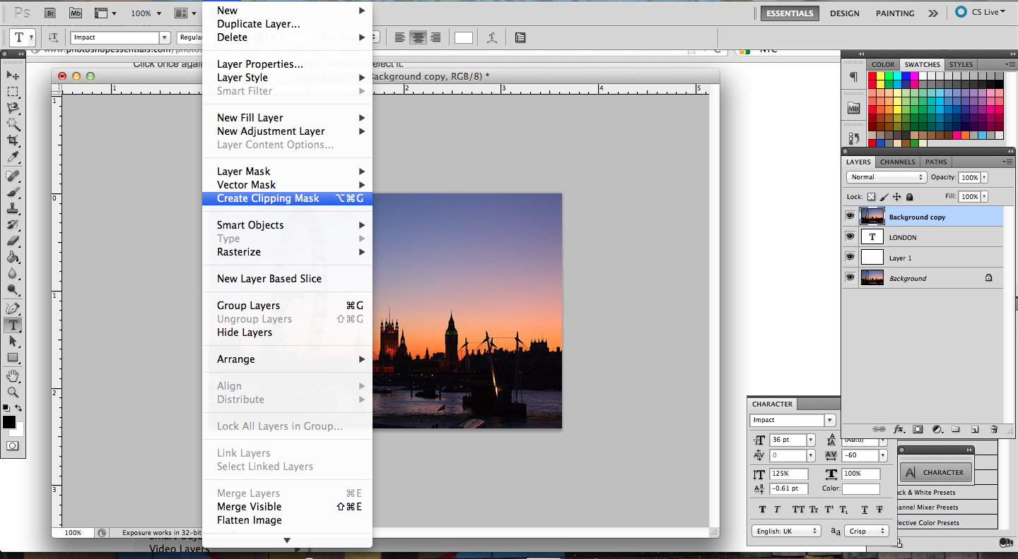

- Your image should now be within the text. Save as a JPEG file in your photography folder.

Your layers should be in a similar order to the layers below...

