MAKING YOUR PHOTOGRAPHS READY FOR YOUR WEBSITE

CHANGING THE IMAGE SIZE

- File/Open your chosen image(s) in Photoshop.
- File/Save As – name the file with web in front of its name. For example, file DSC456.jpg should be renamed webDSC456.jpg.
- Image/Image Size – the dialog box should look like this –

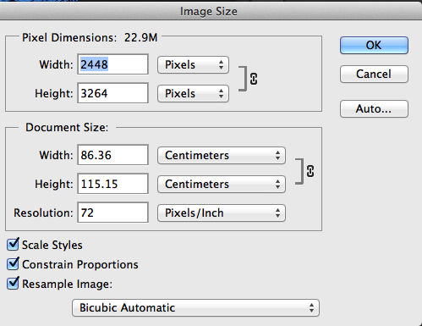

- Make sure ‘Constrain Proportions’ is ticked. Then change the Width to 900 (pixels).
- Save the file (with the same web name).

SAVING THE FILE FOR USE ON THE WEB

- Click on File/Save for Web and you will see something like this –
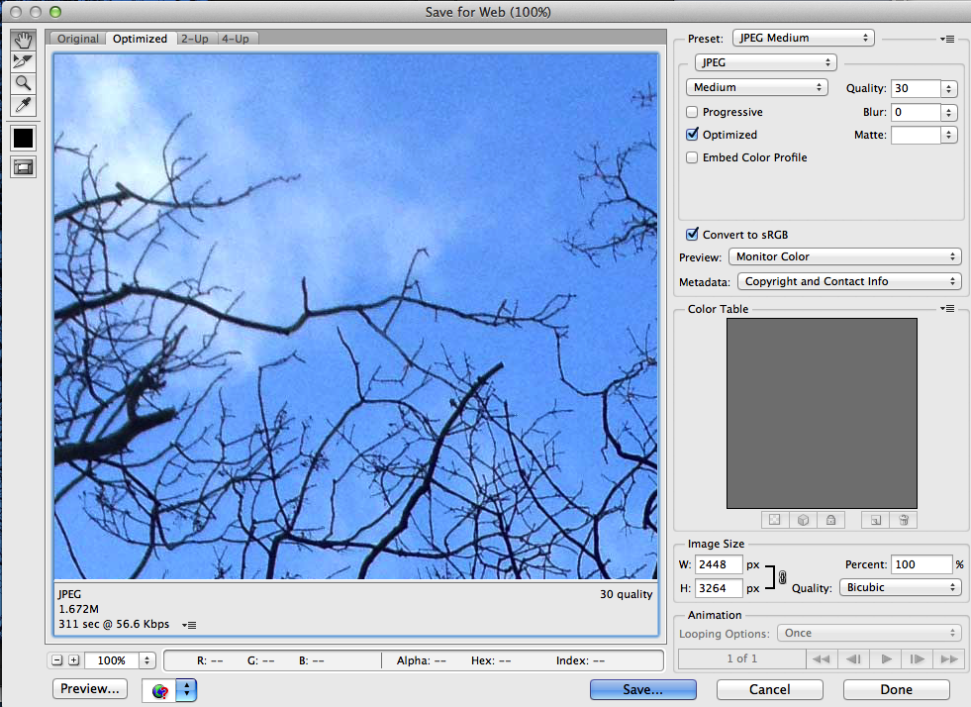
The crucial parts are –

- The file type – make it JPEG.
- The amount of compression – set to Medium.
- The file size should be less than 800k.

Once this is done, save the file using the same web name in a new folder on your desktop called ‘Weebly Photographs’. All images for your website should be kept in that folder.

THIS IS THE ROUTINE THAT YOU MUST FOLLOW WITH ALL IMAGES THAT ARE TO BE UPLOADED

