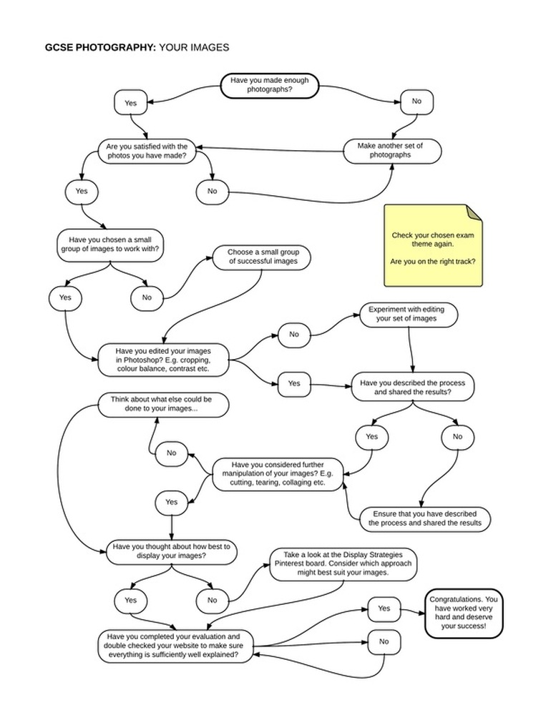

This is a useful guide from Thomas Tallis school. Start at the top and carefully review your work. Only when you can reach the bottom right box should you consider your project complete.