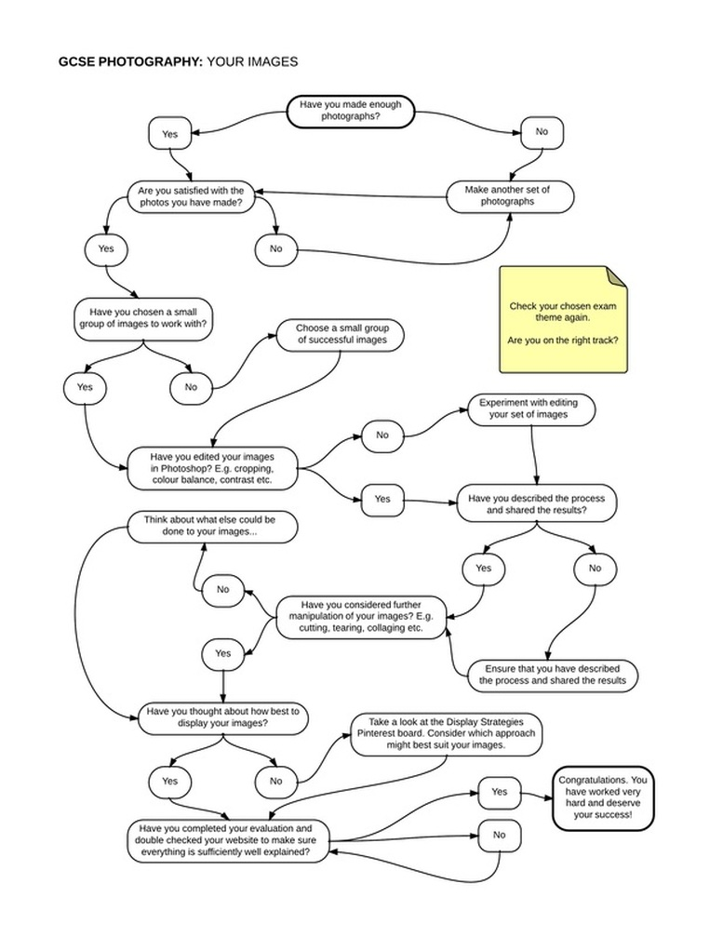
GCSE Photography | STUDENT MARKS | TEACHER MARKS
Assessment Objective 1 - Develop their ideas through investigations informed by contextual and other sources, demonstrating analytical and critical understanding.
Shown a visual and written account of their initial investigations into the theme
Included research of other artists, photographers and other sources
Included creators' work consistently, clearly and correctly
Combined thorough visual and written research in a creative and informative way
Used a wide range of specialist and critical vocabulary to analyse work confidently and effectively
Assessment Objective 2 - Refine their ideas through experimenting and selecting appropriate resources, media, materials, techniques and processes.
Evidence showing your idea being explored, reviewed, refined and improved
Evidence showing different resources being used with relevant explanations
Evidence showing post-processing techniques used (not too much of this) - this evidence is presented in context of you demonstrating your technical skills and understanding of photographic processes

Assessment Objective 3 - Record ideas, observations and insights relevant to their intentions in visual and/or other forms.
Evidence of experimentation using appropriate resources with records kept of this process
Review and reflection on processes followed showing a clear understanding of their work
Continued written work - like a work diary - showing evidence of continued reflection on their work
Reference to other creators' work/techniques where appropriate when planning their own work
Thorough 'diarising' of their own work with clear and detailed records kept of techniques/media used showing a clear understanding of the processes involved
Assessment Objective 4 - Present a personal, informed and meaningful response demonstrating analytical and critical understanding, realising intentions and where appropriate, making connections between visual, written, oral or other elements.
Create a complete piece of work (supported by earlier experimentation, research and recorded processes)
Written content showing a good level of self-appraisal/criticism and reflection
Written content making clear connections with earlier research (other creators' work in ANY forms)
Presented the work effectively and provided evidence of preparatory, reflective and experimental work in this process.
Written an informative piece on the process of presentation with clear and effective analysis and reflection and a wide range of technical vocabulary

GRADING YOUR WORK - A*-A
The written work must be excellent showing clear connections and using appropriate technical vocabulary. The structure of the work must be clear.
AO1 - 5 or more artists/photographers answering ALL of the requirements above in detail - in-depth, wide-ranging
AO2 & AO3 - At least 5 distinct stages of development explaining in detail and accurately from your initial idea to your outcome/final piece
AO4 - Final Piece with detailed explanation of the following -
Your concept - what you wanted to achieve in the work explained in detail
Your influences - who has influenced you from your research and how
Your development of your idea - how do the stages of development link and reach the idea for the final piece
Your conclusion - Review your work - success or failure - what has gone well - what has NOT gone well (and why)

GRADING YOUR WORK - B
The written work must be good, have clear meaning. The work must be fit for purpose.
AO1 - 4 or more artists/photographers answering ALL of the requirements above well
AO2 & AO3 - At least 4 stages of development explaining the journey from your initial idea to your outcome/final piece
AO4 - Final Piece with detailed explanation of the following -
Your concept - what you wanted to achieve in the work
Your influences - who has influenced you from your research and how
Your development of your idea - how do the stages of development link and reach the idea for the final piece
Your conclusion - Review your work - success or failure - what has gone well - what has NOT gone well (and why)

GRADING YOUR WORK - C
The written work is sound and be meaningful with fluent structure. The work is generally fit for purpose.
AO1 - 4 or more artists/photographers answering most of the requirements above well
AO2 & AO3 - At least 4 stages of development giving a good account from your initial idea to your outcome/final piece
AO4 - Final Piece with detailed explanation of the following -
Your concept - what you wanted to achieve in the work explained
Your influences - who has influenced you from your research and how
Your development of your idea - how do the stages of development link and reach the idea for the final piece
Your conclusion - Review your work - success or failure - what has gone well - what has NOT gone well (and why)

