NICOLA DOVE – nicoladove.com

Nicola Dove is a photographer from New Zealand now based in the UK. She specializes in portrait photography.

This worksheet is centered on Dove’s work called ‘Observance’ – a series of portraits of people from different faith groups.

Below is an edited extract from Nicola Dove’s website (www.nicoladove.com) which you may want to use to support your notes –

Observance is a series of long exposure portraits … of people from a wide spectrum of spiritual practices. Sitters were photographed for a fifteen second exposure, each looking into the lens in a state of prayer.

Long exposures hark back to the beginnings of photography, when film was slow and shutter-speeds long. It was the time of spirit photography, where it was commonly believed that a photograph could capture ones soul, or communicate with the dead.

Throughout history religions have tapped into this possibility, where imagery has played an important role in many faiths. Often followers possess an image of their leader, their guru, or their teacher - they have them on their walls, on their altars or tattered in a wallet … Why do people put such faith in the power of a photograph? What can an image hold that is so precious?

Observance raises these questions, and explores how a sense of connection is created through an image, particularly with the sitter gazing out of the frame. This has long been recognized in the art of icon painting, a practice which follows strict spiritual procedures and visual parameters - figures are depicted dominant in the frame, therefore bringing them into direct relationship with the viewer.

This direct engagement is a central theme of Observance...

…These portraits are not split seconds decided upon and captured by the photographer to reveal something of a character. Rather they are an intimate intention unfolding over time…

How could you be influenced and inspired by this work?

- You might want to try out long exposure portraits (15 seconds is a very long time for a portrait).
- You might want to investigate the idea of capturing someone’s soul using photography.
- Investigate how one photo can (or cannot) capture a person?

Look at the photographs on the next page. What do they have in common? What do you like about them? What ideas can you take from them?

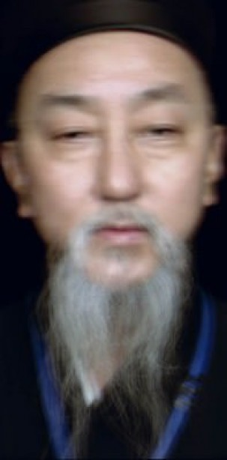
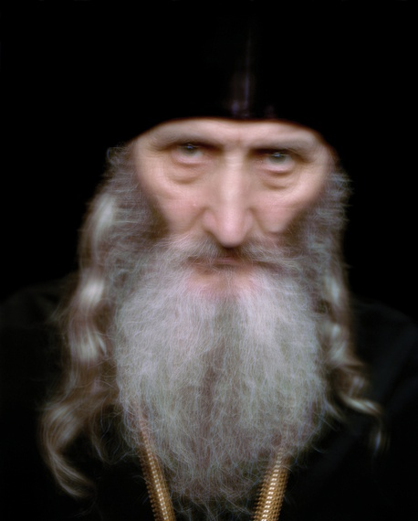

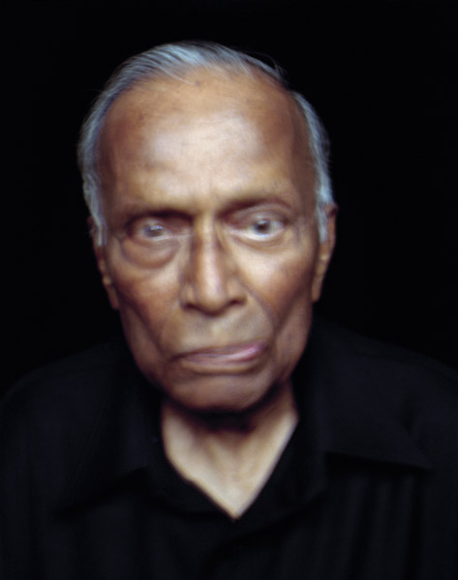

LEE JEFFRIES – leejeffries.500px.com

Lee Jeffries is a British photographer now based in the UK. He specializes in photography around the issue of homeless people in the UK and USA. He has created two big series of photographs called’ Homeless’ and ‘Lost Angels’.

The text below is an extract from his website (www.leejeffries.500px.com) and this explains some of his ideas -

"If you will forgive my indulgence, This work is most definitely NOT photojournalism. Nor is it intended as portraiture. It's religious or spiritual iconography. It's powerful stuff. Jeffries gave these people something more than personal dignity. He gave them a light in their eyes that depicts transcendence, a glimmer of light at the gates of Eden, so to speak. The clarity in their eyes is awesome to behold…

I think Jeffries intended his art to honor these people, not pity them. He honors those people by giving their likenesses a greater meaning. He gives them a religious spiritual significance. He imbues them with the iconic soul of humanity. I think that's what he was trying to do, at least to some degree thereof."

Jeffries is completely devoted to helping homeless people. If he wins a prize he gives it to homeless charities. If he runs a marathon he raises money for homeless charities. He gives money and food to homeless people.

Here is a quote from Jeffries –

“I can’t change these people’s lives,” he says. “I can’t wave a magic wand but it doesn’t mean I can’t take a photograph of them and try to raise awareness and bring attention to their plight.”

This is how he uses photography to make us see the terrible lives of homeless people.

How could you be influenced and inspired by this work?

- You might want to try out making dark portraits and adjusting contrast (levels and curves).
- Concentrate some work around the eyes like Jeffries – make them sharp.
- Think about viewpoint – looking down on people, looking up to people.
- Create a set of portraits around a theme.

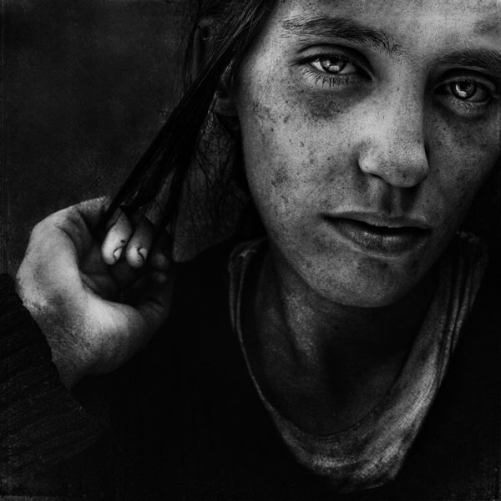
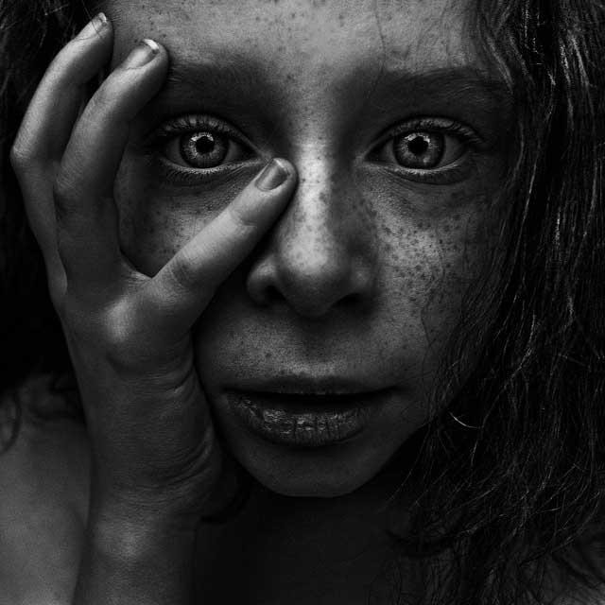
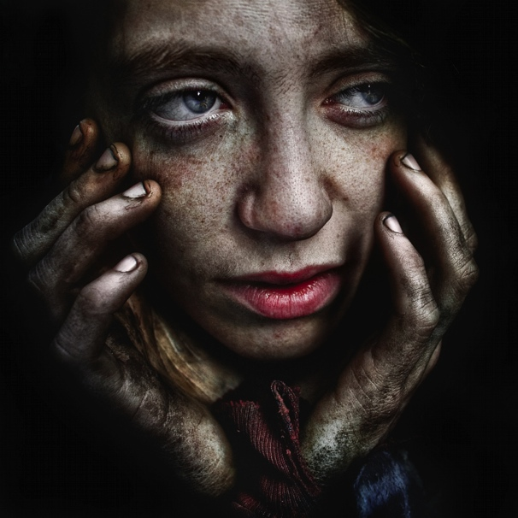
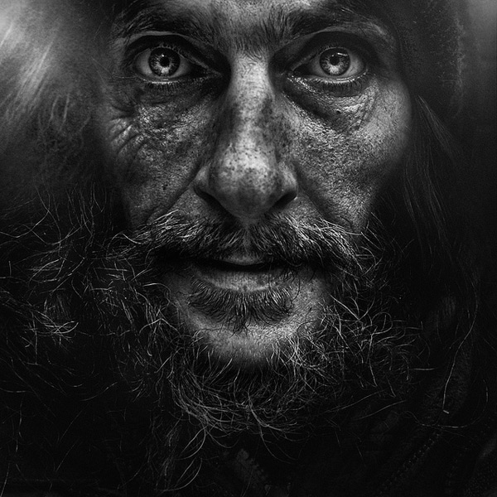
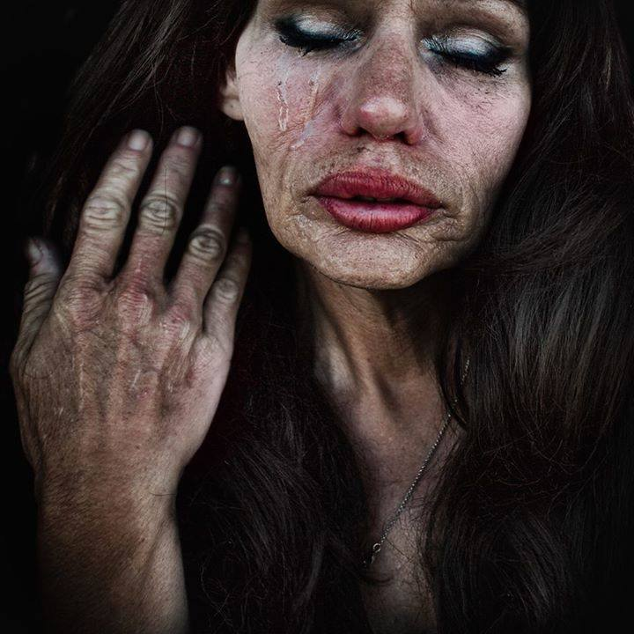
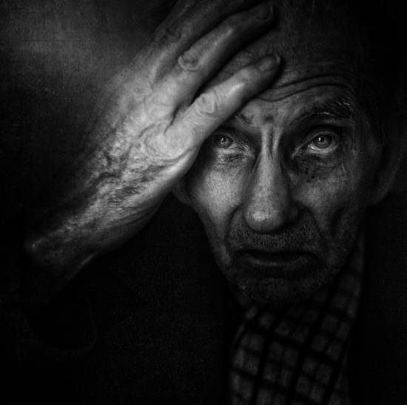
JASPER JAMES – jasperjames.co.uk

Jasper James is a British photographer and he is based in China. The portrait work in this research is from his series ‘City Silhouettes’. This is a series is about connections between the people in his photographs and the places which blend with the people in different ways.

This work looks at showing identity and the poses of the people might suggest what (or how) they are thinking about the place in the background.

- What do you think are the connections between the people and the places?
- Why can we not see some of the faces in the photos?
- How many different combinations of background and portrait can you identify – which do you think works best?

How could you be influenced and inspired by this work?

- Think about identity and how you can take a photograph that shows a likeness of the person and something about their identity or home or cultural background.
- Think about how you could combine images using Photoshop – layers, opacity, blending, selection tools and layer masks.
- Think about how you could you lighting to make silhouettes of people and how this could help combine images.
- Look at how some images have been used as magazine covers and consider possibilities for the use of text with the images you make.

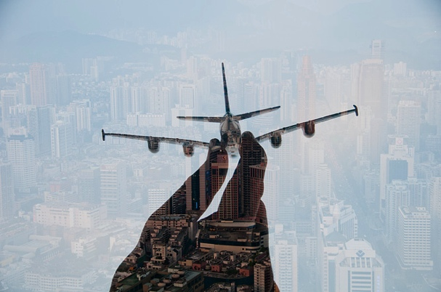
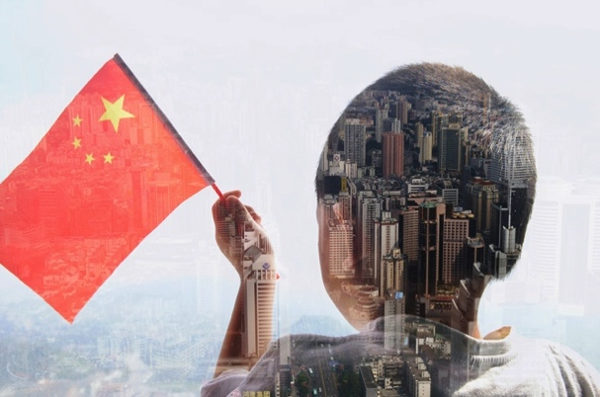

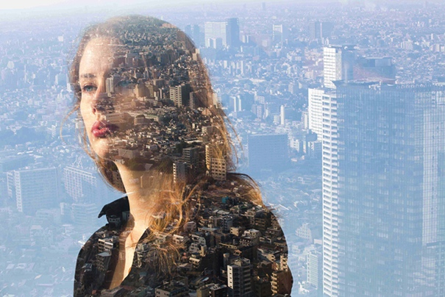
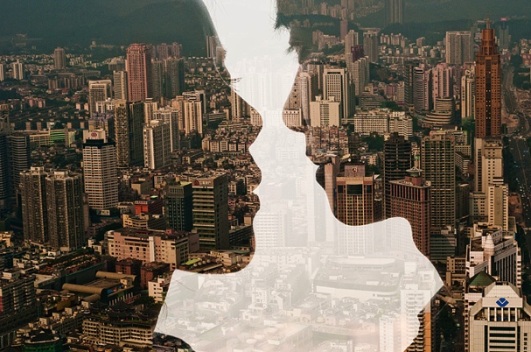
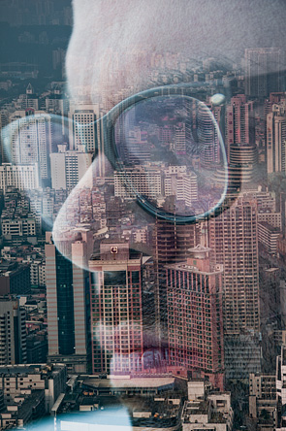
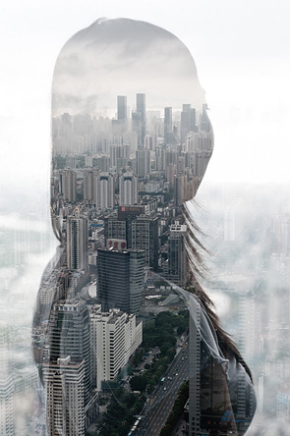
CAMILLA CATRAMBONE - lacatra.com/portfolio/family-portraits/

Camilla Catrambone is an Italian photographer. The portrait work in this research is from his series ‘City Silhouettes’. The portrait work in this research is from her series ‘Family Portraits’.

Catrambone sums up the series like this –

“These portraits aim to represent my family members trough the objects they've owned...”

As she suggests this is about making portraits of people without showing the people themselves. This is a method used by photographers and artists with great success in many cases. The photos all show treasured items and background that come form close family members.

The quotes below are from an interview with Catrambone and give you some more context and ideas about what has motivated her and, in turn, what she intended to produce in her work.

“When I started doing this project, I felt that the objects belonging to my relatives, starting from the ones of my beloved grandparents, were still full of energy and were capable of reminding me of moments I shared with them,” Catrambone stated in an email to The Huffington Post. “I started to feel the need to use them to go back to a precise memory.”
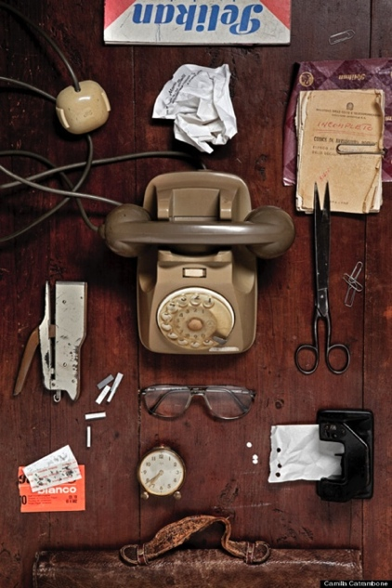
In a portrait of her Grandpa Mario, for example, Catrambone reveals an old telephone, eyeglasses, cigarette papers, a stapler, and more to represent her memory of this particular family member.

“If I look at the image of my grandpa, Mario, I can go back in time when we sat at his writing table and fully feel the mood of that moment,” she added. “The objects represented in the picture don’t express the entire life of my grandpa, but the portrait deeply describes a moment I shared with him.”

How could you be influenced by this work?

Think about would you show to make a self-portrait using this approach?
Think about how you arrange could your framing and compositions differently?
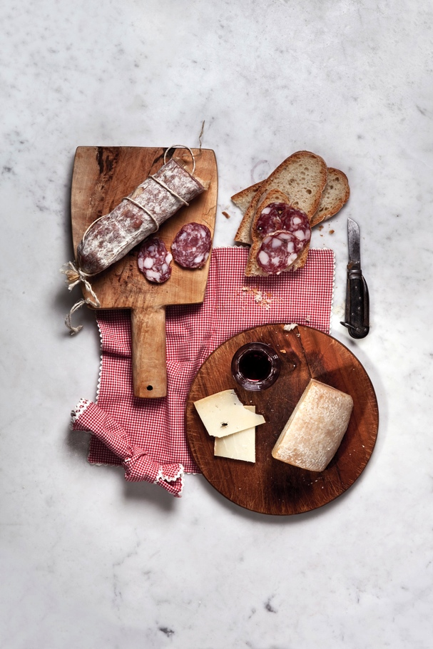
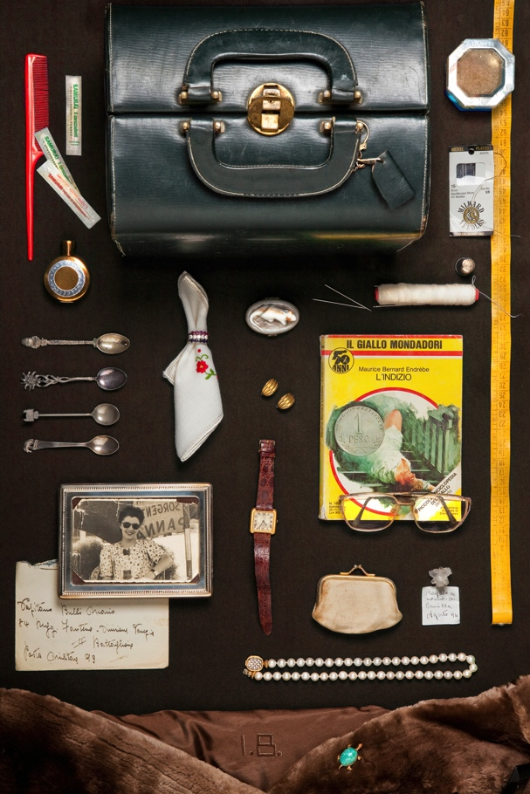
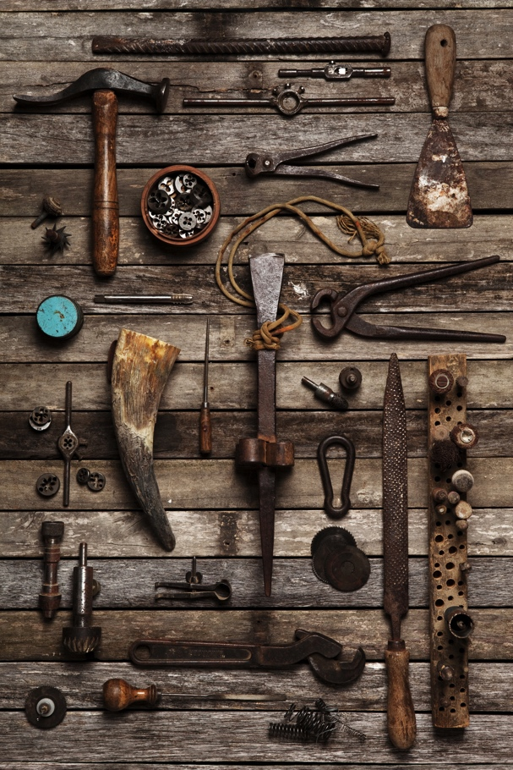
ARNOLD NEWMAN – arnoldnewman.com

Arnold Newman was an American photographer who was born in New York City in 1918 and died there in 2006. He photographed a lot of famous people during his career and most of his work is black-and-white. For most of his career, good quality colour film was not available and most printing (newspapers, books and magazines) was printed only in black-and-white.

“We do not take pictures with our cameras, but with our hearts and minds.”
-Arnold Newman

Arnold Newman was well-known for the way in which he put the sitter (the person he was photographing) in a setting and he is now known as a pioneer of the environmental portrait in photography. The portraits have context because they include background and items that help to portray the sitter.

How could you be influenced by this work?

Think about how you could make your own ‘environmental portraits’.
Think about converting your colour images to black-and-white and just using tone.
Look at his work and his compositions and how he uses shapes in his pictures.
Look at the compositions and how he uses symmetry.

Some quotes from Arnold Newman about his motivations and work -

(But)...a lot of photographers think that if they buy a better camera they'll be able to take better photographs. A better camera won't do a thing for you if you don't have anything in your head or in your heart. - Arnold Newman - "American Photo" - March/April 2000, page: 17

I don’t think any student, any photographer, any person should take pictures the way I take pictures. I build them because it’s the way I am, and that’s the way I should be. If I try to be something else and try to take pictures or talk to you humorously because I think I’ll get a few laughs, no.
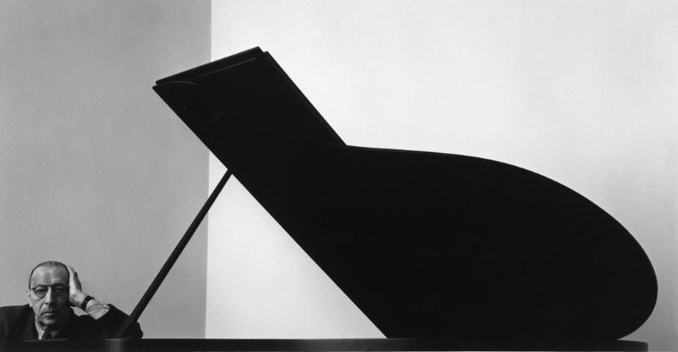
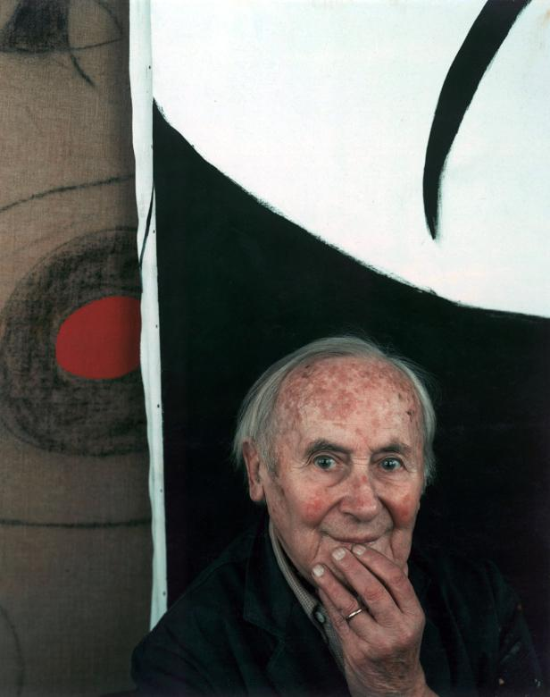
Igor Stravinsky, 1946
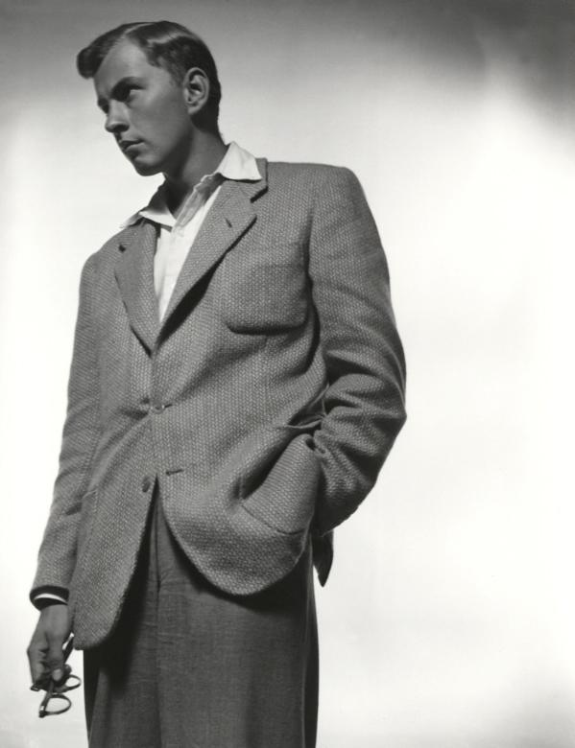
Joan Miro, 1979
Gore Vidal, 1947
MARTIN PARR – martinparr.com

Martin Parr is a British photographer and film-maker and he is well-known for his brightly coloured photography of social occasions and everyday scenes. Most of his work is created in the UK but he has also photographed scenes in America and the far east.

These Martin Parr quotes sum up Parr’s approach to photography and you should read them carefully and can use them when appropriate in your research and notes about your own work -

“I go straight in very close to people and I do that because it's the only way you can get the picture. You go right up to them. Even now, I don't find it easy. I don't announce it. I pretend to be focusing elsewhere. If you take someone's photograph it is very difficult not to look at them just after. But it's the one thing that gives the game away. I don't try and hide what I'm doing - that would be folly.”

“If you photograph for a long time, you get to understand such things as body language. I often do not look at people I photograph, especially afterwards. Also when I want a photo, I become somewhat fearless, and this helps a lot. There will always be someone who objects to being photographed, and when this happens you move on.”

“When I first started learning how to take photographs, you had to spend the first six months figuring out what an f-stop was. Now you just go and take pictures. Nobody thinks about technical issues anymore because cameras or camera phones take care of that automatically. On the other hand, you still have the option of controlling every technical aspect. It’s the most accessible, democratic medium available in the world…”

How could you be influenced by this work?

- Look at Parr’s work and think about how you could use colour to characterize your work and how we see your portraits (or self-portraits).
- After reading the above consider how this could help you in your notes when writing about your approach to your work.
- Think about making portraits without featuring the faces of the sitters. Parr uses this approach regularly in his work.

